ISRO Partners with Manav Rachna University for the Set up of Global Navigation Satellite System (GNSS) & Space Weather Laboratory

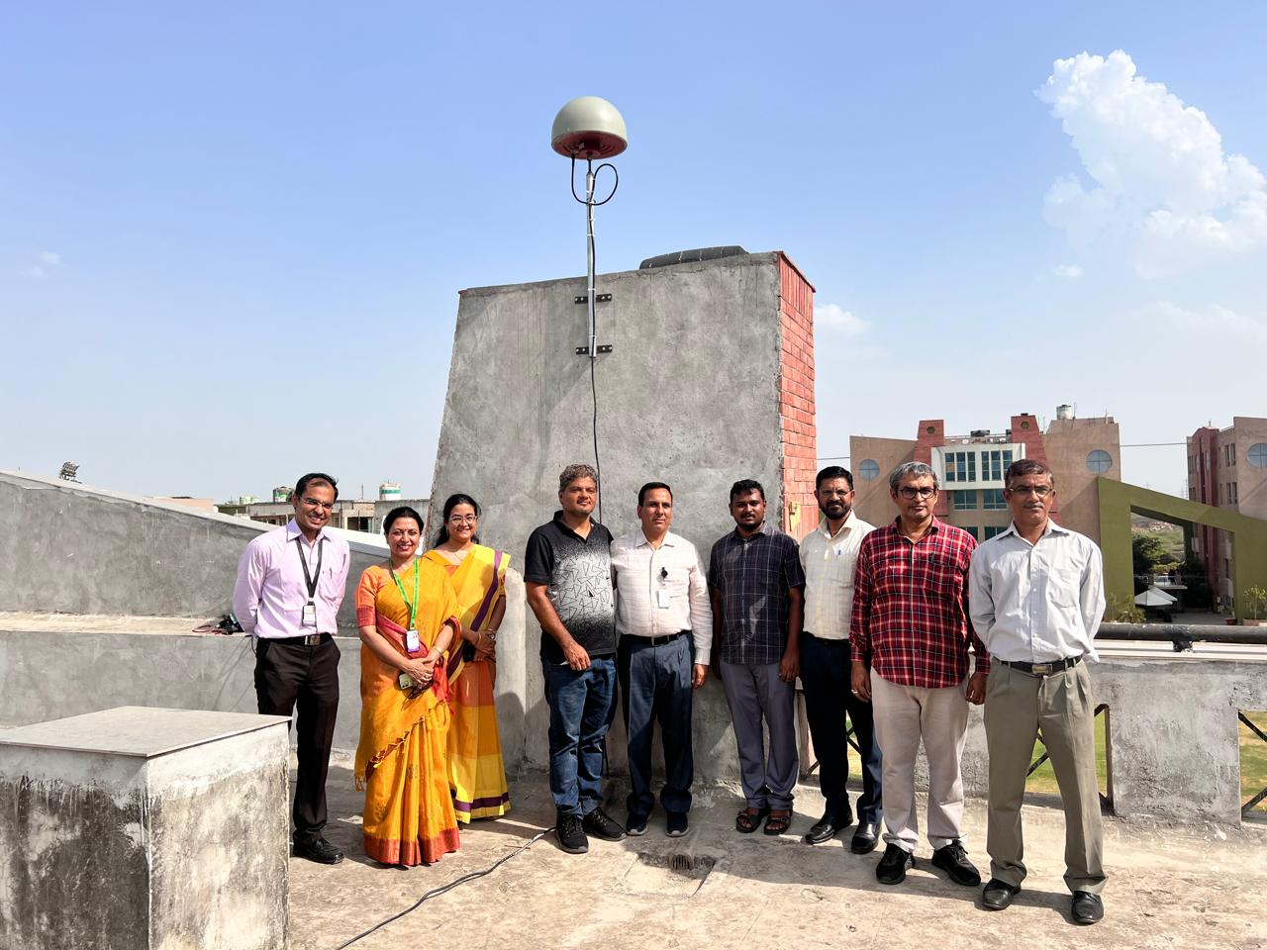

Faridabad, June 14, 2024: Manav Rachna University (MRU) becomes the First University in Delhi NCR to install a Global Navigation Satellite System (GNSS) receiver at Manav Rachna Campus in collaboration with the National Atmospheric Research Laboratory (NARL)-Indian Space Research Organization (ISRO).

A distinguished team of NARL ISRO scientists including Dr. Nirvikar Dashora, Scientist/Engineer-SF and Head of the Ionosphere and Space Physics Group at NARL, Gadanki, AP, Department of Space, GoI, and Mr. Himanshu S. Sethi, Scientist/Engineer-SE facilitated the event. It is one of the initiatives under cooperative research programs of NARL with national institutes and universities, employing GNSS receiver networks. They oversaw the installation of a comprehensive GNSS infrastructure, featuring a GNSS receiver, antenna, 30M RF cable, laptop, and iron mast at the Manav Rachna Campus.

The installation of the Global Navigation Satellite System (GNSS) receiver at MRU is part of the National Atmospheric Research Laboratory (NARL) North-South chain of receivers in collaboration with the ISRO Lab. It encompasses critical studies on weather, climate, space weather, and planetary ionospheres through GNSS receiver networks.
The installation of the GNSS receiver at MRU brings several key benefits. It enables multi-parametric data collection across various atmospheric and space parameters, significantly enhancing research capabilities in atmospheric sciences and related fields. Being a part of the NARL North-South chain of receivers, MRU will be integrated into a broader network of research institutions, fostering collaborative opportunities on both national and global scales. This initiative will also substantially benefit student projects and learning opportunities, particularly for those in the Sciences, Electronics and Communication Engineering (ECE), and Computer Science Engineering (CSE) departments. Students will gain hands-on experience with cutting-edge technology and real-time data analysis. Furthermore, hosting a GNSS receiver as part of a prestigious national network elevates the university's standing within both the Indian and global academic communities.

Prof. (Dr.) Deependra Kumar Jha, VC of MRU, proudly stated, “The installation of a GNSS receiver in collaboration with NARL and ISRO is a landmark achievement. This, along with our newly established space research laboratory, underscores our commitment to pioneering advancements in atmospheric and space research.”
"This is a monumental milestone for the School of Sciences at Manav Rachna University," said Prof. (Dr.) Meena Kapahi, Dean of the School of Sciences at MRU. "This state-of-the-art facility enhances our research capabilities in atmospheric and space sciences, offering our students unparalleled opportunities to engage with cutting-edge technology."
Also present during the occasion were Prof. (Dr.) Meena Kapahi, Dean School of Sciences, Prof. Dr. D. K. Sharma, Dean Examination; Dr. Sandeep Kumar, Head, School of Sciences; Dr. Ananna Bardhan and Dr. Anshuman Sahai; along with faculty members from various disciplines including sciences and engineering.

