Annexure-6
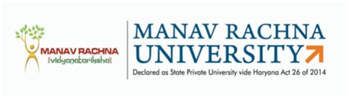
MANAV RACHNA UNIVERSITY
Sector-43, Aravali Hills, Faridabad
Date: ________
Comprehensive Review Report (DRC)

- Name of the Ph. D Scholar : ____________________________________________

- Department : ____________________________________________

- Date of DRC : ____________________________________________

- Registration No : ____________________________________________

- Name of the Supervisor : ____________________________________________

- Name of the Co-Supervisor(if any) :________________________________________

- Broad Research Area :_____________________________________________

- Title of Research Work :_____________________________________________

- Comments/ Suggestions :
_____________________________________________________________________________
_____________________________________________________________________________
_____________________________________________________________________________
The recommendations of DRC on Short Synopsis/Long Synopsis/Draft Thesis is
- Approved with No changes
- Approved with Minor changes
- Approved with Major changes
- Not Approved

DRC Chairperson DRC Member(s) (Name, Designation & Signature)

Note: Send a copy of duly filled report along with copy of DRC invite and DRC MoM to:
- DRC Members
- Supervisor(s)
c) Ph.D. Scholar
d) Ph.D. Office

