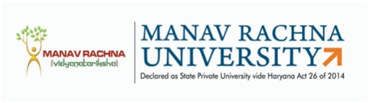
MANAV RACHNA UNIVERSITY
Sector-43, Aravali Hills, Faridabad

Name of the Applicant: __________________
Department: ___________________________
Date: __________________________________
S. No. | Condition | Yes/No
1 | Bonafide registered Research scholar of the recognized University
2 | Fulfilled all the eligibility conditions for Ph.D admission
3 | Completed the Course work with the minimum stay of one year in the University where registered
4 | Status of research work completed as on date by the student duly verified by the Guide (Attach Publication in Journal and Conferences)
5 | Valid reasons for migration (Application from candidate)
6 | No Objection Certificate issued by the Research Guide
7 | Migration Certificate by University
8 | Research plan in association with the proposed Guide in Manav Rachna University. (DRC members will take a presentation of the candidate and allot guide/supervisor. DRC minutes to be attached along with file)
9 | Declaration form for admission to Manav Rachna University
10 | DRC Approval

NOTE:
- Registration period for a migrated candidate shall not be less than one year.
- In case of migrated candidates at least one publication shall show affiliation of MRU.

