Annexure-10
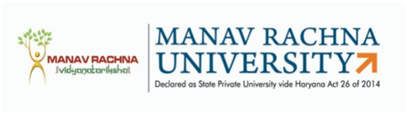
MANAV RACHNA UNIVERSITY
Sector-43, Aravali Hills, Faridabad

PERFORMA FOR ELIGIBILITY
Date: __________________
- Name of Ph.D Scholar : ___________________________________________
- Name of Department : ___________________________________________
- Batch : ___________________________________________
- Date of Registration : ___________________________________________
- Registration No : ___________________________________________
- Title of Research (as per approved short synopsis): _______________________________________________________________

- Details of Journal Publications:

S. No | Title of Paper | Name of Author  (s) | Name of Journal with ISSN No. | Vol. (Issue), Pg. No. Year of Publication | Journal Indexing  (Scopus/ WoS etc.) | Impact Factor | Whether Payment Made To The Publisher, If Yes Mention the Amount | Evaluation Score͙͙ ̽
 |  |  |  |  |  |  |  | Scholar  (Self-assessment) | Supervisor(s)  (Verified) | DRC Chairperson  (Awarded)

(B.) Conference Publications:
S.No | Title of Paper | Name of Author  (s) | Name and Place of Conference | Organizer &Sponsors | Proceeding details & Year of Publication | Evaluation Score͙͙ ̽
 |  |  |  |  |  | Scholar  (Self-assessment) | Supervisor(s)  (Verified) | DRC Chairperson  (Awarded)
.

̽ Journal: International-10; National-5
̽ ̽ Conference Presentation: Outside India-5; International (In India)-3; National-2

Signature of Ph.D. Scholar Name & Signature of Supervisor Name & Signature of DRC Chairperson

Dy. Director, Doctoral Program Approved by Dean Academics

