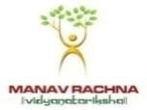
MANAV RACHNA UNIVERSITY, FARIDABAD
Sector 43, Aravalli Hills, Manav Rachna Campus Rd, Faridabad, Haryana 121004

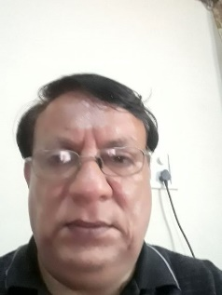
Name: Sanjay Taneja

Designation: Associate Professor

Qualifications: B.E. M.Tech

Email : sanjay@mru.edu.in
Experience : 35.5 Years

Research Interest : Hydraulics, Balancing technology

+ Journal Publication Details:
1-Effect Of Tyre Unbalance on Performance Of Vehicle-International Journal of Mechanical Engineering and Technology (IJMET) Volume 11, Issue 12, December 2020, pp. 12-18
Journal Impact Factor (2020): 11.2184 (Calculated by GISI) www.jifactor.com ISSN Print: 0976-6340 and ISSN Online: 0976-6359
IAEME Publication Scope Database Indexed

2- LPG (Liquified Petroleum Gas) as a Fuel
DOI : https://dx.doi.org/10.26808/rs.ed.i8v3.05
International Journal of Emerging Trends in Engineering and Development Issue 8, Vol.3 (April- May 2018) Available online on http://www.rspublication.com/ijeted/ijeted_index.htm ISSN 2249-6149

+ Conference Publications:
Paper published on Title- Balancing Methodology for Blower
ICRACI 4.0- 2021-Conference in MRU

+ Research Supervised:
NA

+ Book/Chapter Publications:
NA

+ Administrative Responsibilities:
Alumni Coordinator
Examination Superintendent
Lab In charge

+ Professional Affiliation:
Society of Automotive Engineers (SAE)

+ Expert for various organizations:
NA

+ Expert for WORKSHOPS/Sessions/FDP:
NA

+Faculty Development Programme
Human Values in Technical Education – AICTE- 25/10/21 to 29/10/21
NBA Accreditation of Engineering Program – NITTR Chandigarh- 11/05/20 to 15/05/20
Renewable & Sustainable Energy Conversion System- Manav Rachna University Faridabad- 15/06/20 to 20/06/20

+In-house trainings

+ Organized FDPs/seminar/workshops:

+Awards
Article published in Haryana Magazine Edition- March 2021.
Title-BLOOMING OF START UP CULTURE IN INDIA

+ Courses Designed
Fluid Mechanics and Machine

