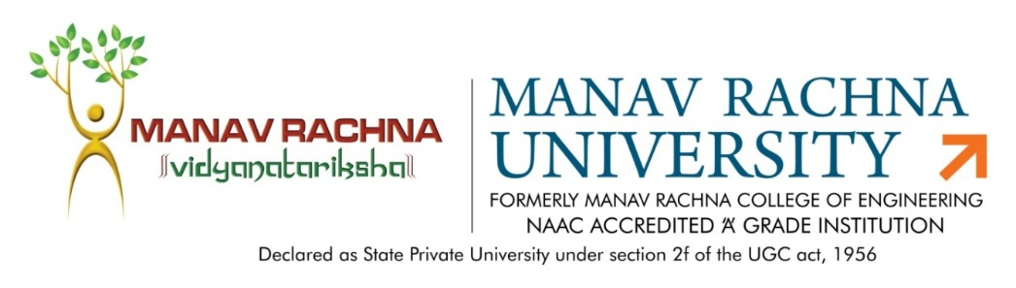

Dated: 30th July, 2022

MINUTES OF MEETING

The Board of Studies (BoS) meeting for the Department of Mechanical Engineering, Manav Rachna University, was conducted on 30th July, 2022. The BoS was started by Mr. Sanjay Taneja with the welcome of External Members. The brief of Agenda Points was given to all members and handed over to faculty members to discuss the various Agenda Points.

Agenda Points

The following were the agenda points for discussion during the meeting:

Agenda No. | Agenda | Responsibility
01 | New Curriculum and Syllabus designed for B. Tech UG program in Robotics and Artificial Intelligence course. | Mr. Gianender Kajal
02 | Pattern of Examination change from T1, T2 and T3 to Mid Term and End Term. | Mr. Gianender Kajal
03 | Physics subject updated. | Mr. Piyush Mahendru
04 | Value Added Courses for B.Tech and M.Tech Courses. | Mr. Piyush Mahendru
05 | Reduce the practical timing of Engineering Drawing and Graphics from 3 to 2 classes. Reduce the credits from 1.5 to 1. | Dr. Prashant Bhardwaj
06 | Approval of Course Assessment Plan (CAP) of various UG and PG courses previous semester and coming semester. | Dr. Prashant Bhardwaj
07 | Approval of the list of External Examiner for the End Term of Theory and Practical Subjects. | Mr. Sanjay Taneja
Members of BOS - Mechanical Engineering

The following members were present in the meeting:

S.No. | Name | Designation | Membership
01 | Prof. (Dr.)  Sandeep Grover | J.C. Bose University of Science and Technology, YMCA | Academic  External  Expert
02 | Mr. Amit Singh | Business Head  Akriti Design  Faridabad | Industry  External  Expert
03 | Mr. Gautam Ahuja | Technical Curriculum Developer, BYJU’s | Alumni
04 | Prof. (Dr.)  Joginder Singh | HoD, ME  Professor | Chairperson
05 | Mr. Ajit Katiyar | Associate  Professor | Member
06 | Mr. Sanjay Taneja | Associate  Professor | Member
07 | Mr. Piyush Mahendru | Assistant  Professor | Member
08 | Dr. Prashant Bhardwaj | Assistant  Professor | Special Invitee
09 | Mr. Gianender Kajal | Assistant  Professor | Special Invitee

Key Conclusive Points

Agenda 1
New Curriculum designed for B. Tech UG program in Robotics and Artificial Intelligence course.
- The Faculty coordinator presented the New Curriculum designed for B.Tech UG program of Robotics and Artificial Intelligence.
- The Industry External Expert (Mr. Amit Singh) suggested the transfer of “Entrepreneurship and Startups” subject from 7 Semester to 4 Semester. Academic External Expert (Dr. Sandeep Grover) was also agreed with the suggestion.
- Academic External Expert (Dr. Sandeep Grover) suggested to take advice from Dr. Mohammed Suhaib for the syllabus/workshop Updation. Dr. Suhaib is a Professor in Department of Mechanical Engineering, Faculty of Engineering & Technology,
Jamia Millia Islamia (A Central University), 9868853897, msuhaib@jmi.ac.in.
- Academic External Expert (Dr. Sandeep Grover) suggested to take Teacher Training Program on Robotics from YMCA, Faridabad. The concerned people for the training are chairperson.me@jcbose.ust.ac.in and Dr. Raj Kumar.
- Academic External Expert (Dr. Sandeep Grover) suggested to take Students Training Program on Robotics from NITTTR, Chandigarh. He also suggested some professors like Dr. S S Dhami, Dr. Hariom and Professor Lakhvinder.
- Members were satisfied with the efforts of the ME Department to develop the New Curriculum.

Agenda 2
Pattern of Examination changed from T1, T2 and T3 to Mid Term and End Term.
- The Faculty coordinator presented the Old and New Pattern of the examination to the members.
- Mid Term would be of 30 Marks.
- Continuous Evaluation would be 70 Marks.
- End Term would be 100 Marks.
- Members were satisfied with the efforts of the ME Department to develop the New Examination Pattern.

Agenda 3
Physics subject updated.
- Members were satisfied with the efforts.

Agenda 4
Value Added Courses (VAC) for B.Tech and M.Tech Courses.
- Academic External Expert (Dr. Sandeep Grover) suggested to offer minimum one VAC during the B.Tech and M.Tech Program for the students.
- One VAC should be mandatory for the every student of B.Tech and M.Tech.
- VAC should be visible or reflect in the mark sheet of the students.

Agenda 5
Reduce the practical timing of Engineering Drawing and Graphics from 3 to 2 classes. Reduce the credits from 1.5 to 1.
- Members were satisfied with the efforts.

Agenda 6
Approval of Course Assessment Plan (CAP) of various UG and PG courses previous semester and coming semester.
- Academic External Expert (Dr. Sandeep Grover) suggested to conduct End Term Examination in case of Project Based Learning (PBL) also.
- Members were satisfied with the efforts.

Agenda 7
Approval of the list of External Examiner for the End Term of Theory and Practical Subjects.
- Academic External Expert (Dr. Sandeep Grover) suggested to add more names in the examiner list from different university or colleges like YMCA, DTU, NSUT, AMU, etc.

