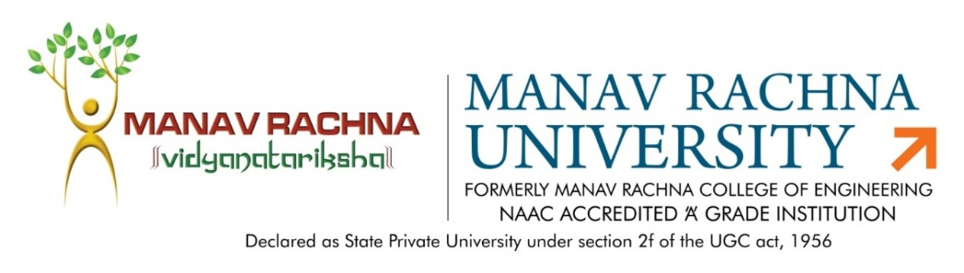

Dated: 7th January, 2021

Subject: Agenda for BoS Meeting
Date: 7th Jan, 2021
Time: 2:00 PM-3 PM (Through Video Conferencing)
Agenda:
1. Discussion and approval of Course outline designed for Industrial Automation Certification Program by Industry Partner Trans Neuron Technology
2. Discussion and approval for Recommencement of B. Tech Core Mechanical Engg.

The following members were present in the meeting:

- Dr. Sandeep Grover, Prof. (Mechanical Engg.) & Dean- Quality Assurance, JC Bose University of Science- External Expert

- Dr. Sujata Nayak, HoD-ME- Chairperson
- Mr. Joginder Singh, Asso. Head-ME, Assoc. Prof-Member
- Mr Ajit Katiyar, Assoc. Prof., Mechanical Deptt.- Member
- Mr. Sanjay Taneja, Assoc. Prof. Mechanical Deptt.- Member
- Mr. Piyush Mahendru, Assistant. Prof., Mechanical Deptt. (Special Invitee)
- Mr. Prashant Bhardwaj, Assistant. Prof., Mechanical Deptt. (Special Invitee)
- Mr. Gianender Kajal, Assistant. Prof., Mechanical Deptt. (Special Invitee)
- Mr. J.P.Sharma, Assistant. Prof., Mechanical Deptt. (Special Invitee)

The following were the agenda points for discussion during the meeting:
- Discussion and approval of Course outline designed for Industrial Automation Certification Program, by Industry Partner Trans Neuron Technologies with which Manav Rachna University has signed MoU on 28th October, 2020 for B. Tech Smart Manufacturing and Automation students.
- Discussion and approval for Recommencement of B. Tech Core Mechanical Engg. programme.
Key Conclusive Points
- The External Member and Alumni discussed the course outline, designed for Industrial Automation Certification Program, by Industry Partner Trans Neuron Technologies and approved the same. They appreciated that this collaboration will help students to be Industry ready and improve their prospects for corporate placement
- They have approved the recommencement of B. Tech Core Mechanical Engg. and B. Tech Specialization course with 30 seats each from the academic year 2021-22.

