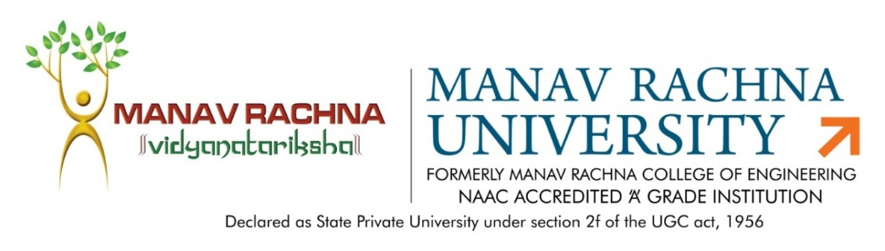

Dated: 15th April, 2020

MINUTES OF MEETING
Subject: Agenda for BoS Meeting
Date: 15th April, 2020
Time: 9:30 pm-11 am (Through Video Conferencing)
Agenda:
1. Discussion of Revised B. Tech Mechanical Engg. (Specialization Smart Manufacturing and Automation Program structure as per latest AICTE Hand Book-2020-21.
2. Discussion and approval of MOOC Courses to be offered in the Mechanical Engineering Discipline during July-August session by NPTEL.
3. Discussion and approval for changing the L-T-P mode of some subjects of the mechanical Engg. Courses.
4. Discussion and approval on the weightage to weekly assessment, T1, T2 and End Term examination.

The following members were present in the meeting:

- Dr. Sandeep Grover, Prof. (Mechanical Engg.) & Dean- Quality Assurance, JC Bose University of Science- External Expert

- Mr. Lakshay Sharma, Senior Patent Analyst, Sagacious Research- Alumni
- Dr. Sujata Nayak, HoD-ME- Chairperson
- Mr. Joginder Singh, Asso. Head-ME, Assoc. Prof-Member
- Mr Ajit Katiyar, Assoc. Prof., Mechanical Deptt.- Member
- Mr. Sanjay Taneja, Assoc. Prof. Mechanical Deptt.- Member
- Mr. Piyush Mahendru, Assistant. Prof., Mechanical Deptt. (Special Invitee)
- Mr. Prashant Bhardwaj, Assistant. Prof., Mechanical Deptt. (Special Invitee)
- Mr. Gianender Kajal, Assistant. Prof., Mechanical Deptt. (Special Invitee)
- Mr. J.P.Sharma, Assistant. Prof., Mechanical Deptt. (Special Invitee)

The following are the key points discussed and approved during the meeting:
- The external expert and alumni approved the increase of credit points from 160 to 180 for B.Tech (Mech.) Specialization Course as per the latest AICTE guidelines for specialization Hons. courses.
- They also offered the following suggestions on the program structure:
  - The department can offer specialization Hons. or Minor Degrees, which will cumulatively require additional 18-20 credits in specified area or specialized subject in addition to the credits essential for obtaining the B. Tech in Major discipline (i.e 160 credits) which will help in employability opportunities for students. They suggested that the department can offer minor specialization in subjects like Artificial Intelligence, Data Sciences, 3 D Printing and Robotics.

- They have approved the list of MOOC Courses by NPTEL which the department is offering to Mechanical Engineering Students. The list of courses is as follows:
  - Introduction to Industry 4.0 and Industrial Internet of Things (12 Weeks) to 3rd Sem SMA Students
  - Mechanism And Robot Kinematics (8 Weeks) to 5th sem ME Students
  - The Future of Manufacturing Business: Role of Additive Manufacturing (8 Weeks) to 7th ME Students
  - Optimization from Fundamentals (12 Weeks) to IEM-7th sem students

- They have approved of L-T-P mode of some subjects in which Laboratory Components are not required. The subjects are Non-Conventional Energy Sources, Supply Chain Management and Quality Engg etc.

- They also suggested that Evaluation of End Semester Examination decision should be decided centrally and conducted uniformly across the University.

