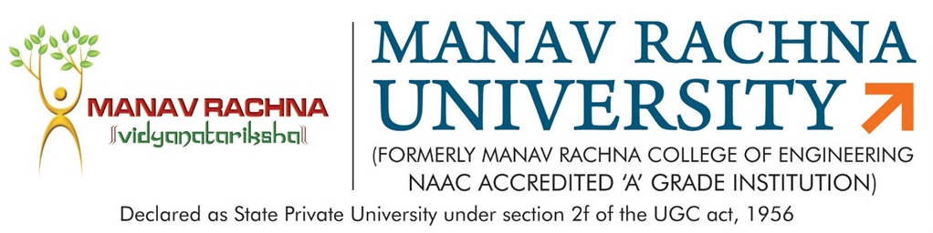
Dated: 16th April, 2018
MINUTES OF MEETING
Subject: MRU - B. Tech (ME) Program Structure
Date: 16th April 2018
Time: 9:30 am - 1:00 pm
Venue: HG -14

Agenda:
- Revision of B. Tech Mechanical Engg. Program/Course structure and Syllabus as per AICTE model curriculum.
- Discussion of M. Tech Mechanical Engg. (Specialization Manufacturing and Production) Program/Course structure and Syllabus
- Approval of list of External Examiner

The following members were present in the meeting:
- Dr. Sujata Nayak, HoD-ME, Chairperson
- Mr. Joginder Singh, Asso. Head-ME, Assoc. Prof.
- Gautam Malhotra, Director, Bhartiya Valves Pvt. Ltd. (External Member)
- Dr Vasdev Malhotra, Professor, YMCA University (External Member)
- Mr Ajit Katiyar, Assoc. Prof., Mechanical
- Mr. Sanjay Taneja, Assoc. Prof. Mechanical
- Mr. Piyush Mahendru, Assistant. Prof., Mechanical (Special Nominee)
- Mr. Prashant Bhardwaj, Assistant. Prof., Mechanical (Special Nominee)

Key Points Discussed:
  - Department revised the program structure and syllabus of B. Tech Mechanical Engineering as per AICTE model curriculum.
  - Credits of B. Tech Programme reduced from 196 (2017) to 152.5 (2018).
  - Courses for First year in all streams should follow AICTE norms and guidelines.
  - Major reshuffle in structure suggested by AICTE must be avoided as suggested by AICTE.
  - Subject name should be displayed in full form such as CNC, TQM and PPC etc.
  - Mandatory course such as foreign language & CDC must be displayed against MOOC course.
  - Research Methodology should be displayed in scheme.
  - One industrial subject should be introduced, which will be taught by industrial expert & faculty of MRU in 8th semester.
  - Production, planning and Control (PPC) & Statistical, Quality and Control (SQC) should be introduced instead of Total Quality Management (TQM).
  - CDC name should be changed to Proficiency competency enhancement.
  - Industry participation to be increased by introducing Industry Oriented course, if possible, lecture can be given by Industry Specialist.
  - Industry specific subjects like 3D software, Production, planning and Control, Quality Management, CNC should be taught in detail with lab experience. Industry Exposure by regular visits and interaction with Industry Experts should be increased.
  - Suggestions have been given for reducing M. Tech. Course credit from 98 to 78 credits as per AICTE guidelines.

