MANAV RACHNA UNIVERSITY, FARIDABAD
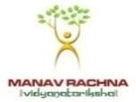
Sector 43, Aravalli Hills, Manav Rachna Campus Rd, Faridabad, Haryana 121004

Prof. (Dr.) Joginder Singh  Designation: Professor, HoD-Mechanical Engineering  Qualifications: PhD (Carbon Fiber Composites)  Email: joginder@mru.edu.in, hodme@mru.edu.in  Experience: 20 Years  Google Scholar Profile | 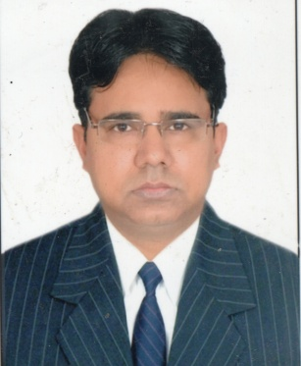
Research Interest:
Carbon Fiber Reinforced Composites, Product Design, Product Analysis, Manufacturing, Development, 3D Printing, Tool Design, Tool Analysis, Robotics.
Membership:
American Society of Mechanical Engineers (ASME)
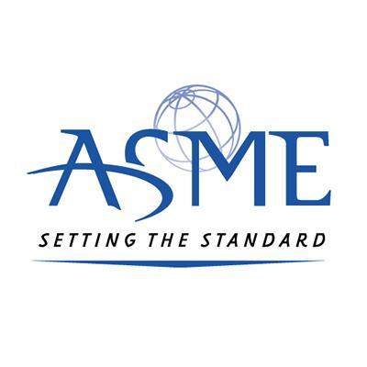
Journal Publication Details:
1) Joginder Singh and M.R.Tyagi, “Effect of Angular Orientation of Continuous Fibers on the Extensional Properties of Carbon Fiber Composites”, Lecture Notes in Mechanical Engineering, ISSN No.: 21954356, 21954364, Springer Nature , https://doi.org/10.1007/978-981-15-5519-0_1, Sep 2020.

2) Joginder Singh and M.R.Tyagi, “Evaluation of Tensile Properties of Hot Rolled Carbon Steel Using Finite Element Analysis”, Lecture Notes in Mechanical Engineering, ISSN No.: 21954356, 21954364, Springer Nature, https://doi.org/10.1007/978-981-13-6469-3_35, April 2019.

3) Joginder Singh and M.R.Tyagi, “Comparative Study of Sheet Metal and Carbon Fibre Reinforced Composites Ceiling Fan Blade”, Lecture Notes in Mechanical Engineering, ISSN No.: 21954356, 21954364, Springer Nature, https://doi.org/10.1007/978-981-13-6577-5_39, June 2019.

4) Joginder Singh and M.R.Tyagi, “Analysis of Stresses and Deflections in Spur Gear”, International Journal of Mechanical Engineering and Technology, ISSN No.: 09766340, 09766359, Volume 8, Issue 4, pp. 461–473, Article ID: IJMET_08_04_050, April 2017.
Conference Publications:
1) Joginder Singh and M.R.Tyagi, “Variation of Shear Properties in Carbon Fiber Composites as Extensional Forces Applied with Different Fiber Orientation”, International Conference on Mechanical and Energy Technologies (ICMET), 2019, November, Galgotia College of Engineering & Technology, Greater Noida, UP, Smart Innovation, Systems and Technologies, 427-438, https://doi.org/10.1007/978-981-15-2647-3_38.

2) Joginder Singh and M.R.Tyagi, “Design, Analysis and Manufacturing of Front Sprocket of a Bicycle using Carbon Fiber Reinforced Plastics”, New Frontiers in Engineering, Science & Technology (NFEST), 2019, February, , International Conference, NIT, Kurukshetra, IOP Conf. Series: Journal of Physics: Conf. Series 1240 (2019) 012071, IOP Publishing, doi:10.1088/1742-6596/1240/1/012071.

3) Joginder Singh and M.R.Tyagi, “Virtual Analysis And Manufacturing of Flat Specimen of Carbon Fiber Composite For Tensile Strength”, National Conference on Trends and Advances in Mechanical Engineering (TAME), 2019, April, J.C.Bose University of Science and Technology, YMCA, Faridabad, Haryana. (Best Paper Award under the Theme of Production & Manufacturing)

4) Joginder Singh and M.R.Tyagi, “Design and Manufacturing of a holding fixture to test the tensile strength of a flat specimen”, International Conference on Recent Trends and Innovations in Mechanical Engineering (ICRTIME), 2018, July, KIET Group of Institutions, Ghaziabad, UP, International Journal of Applied Engineering Research ISSN 0973-4562 Volume 13, Number 6 (2018) pp. 1-6, Research India Publications.
Administrative Responsibilities:
- Head of Department (Mechanical Engineering), MRU, Faridabad
- Member of Academic Council
- Chairman, Board of Studies (BOS), Mechanical Engineering
- Chairman, Departmental Research Committee (DRC), Mechanical Engineering
CAD/CAE Certification:
- Certificate of Achievement for completing the course on “SimSolid Advanced Examination” from Altair University.
- Certificate of Achievement for completing the course on “HyperMesh Intermediate Examination” from Altair University.
- Certificate of Achievement for completing the course on “CATIA V5R18 Product Design Specialist” from Dassault System, France.
MOOC Courses:
- Certificate awarded for successfully completing the course on “Product Design and Development” from NPTEL.
- Certificate awarded for successfully completing the course on “Processing of Polymers and Polymer Composites” from NPTEL.
- Certificate awarded for successfully completing the course on “Introduction to Composites” from NPTEL.
- Certificate awarded for successfully completing the course on “Advanced Composites” from NPTEL.
- Certificate awarded for successfully completing the course on “A Hands on Introduction to Engineering Simulation” from Edx and Cornell University.

Workshop Organized:
- Certificate for successfully organizing the technical workshop on “Mould Manufacturing By Composite Material” in Mechanical Engineering Department at Manav Rachna University, Faridabad.
Workshop Attended:
- Certificate for successfully completing the technical workshop on “Scanning Metrological Inspection and Reverse Engineering” from G-Steam India Private Limited and K.R.Mangalam University, Gurgaon.
Faculty Development Program (FDP):
- Certificate of Participation for completing the 5 Days online FDP on the theme “Inculcating Universal Human Values in Technical Education” organized by AICTE.
- Certificate of Participation for completing the 5 Days online FDP on the theme “Product Design and Drafting using CATIA V5” organized by ICT Academy.
- Certificate of Participation for completing the 3 Days FDP on the theme “Faculty Development Program for Student Induction (FDP-SI)” organized by AICTE at YMCA, Faridabad.
- Certificate of Participation in a awareness program on the theme “Prime Minister’s Scheme Zero Defect and Zero Effect Manufacturing” organized by MSME-DI, Delhi at Manav Rachna University, Faridabad.
- Certificate of Participation for completing the 5 Days FDP (Quality Improvement Program – QIP) on the theme “Make in India: Innovative Product Design” organized by IIT, Delhi.

